**Chapter 1**

**Introduction**

**Administrator's Hub:**

As the guardian of the Cinemax realm, administrators wield the power to orchestrate the perfect cinematic symphony. With unparalleled authority, they oversee every aspect of the system, from managing customers to nurturing relationships with theatre owners. The administrative dashboard provides a comprehensive view, allowing for effortless navigation through customer databases and theatre owner directories. Equipped with the ability to delete customers and theatre owners when necessary, administrators ensure the seamless functioning of Cinemax.

**Theater Owner's Corner:**

For theater owners, Cinemax is not just a platform; it's a stage to showcase cinematic brilliance. Empowered with the ability to add movies and set show timings, theater owners transform their venues into cinematic sanctuaries. Through the intuitive interface, they curate a captivating lineup of films, tailored to tantalize the senses of every moviegoer. With Cinemax, theater owners reignite the magic of cinema, one screening at a time.

**Customer's Oasis:**

Step into the world of Cinemax, where movie magic awaits at your fingertips. As a customer, your journey begins with a simple search, as you explore an extensive collection of movies and show timings. From the comfort of your own device, you can effortlessly browse, select, and book your preferred screenings with ease. With secure transactions and instant confirmations, Cinemax ensures that every movie experience is nothing short of extraordinary.

At Cinemax, we don't just offer a Movie Booking System; we present an immersive cinematic journey. Whether you're an administrator, a theater owner, or a valued customer, Cinemax invites you to embark on an unforgettable adventure, where the magic of movies comes to life. Welcome to Cinemax – where every moment is a masterpiece.

**Objective of study**

The objective of developing the Movie Booking System is to create a seamless and efficient platform that caters to the diverse needs of administrators, theater owners, and customers within the realm of movie entertainment. This system aims to achieve several

**Key objectives:**

1. Streamlined Operations: Simplify the process of movie booking and management for all stakeholders involved, minimizing manual efforts and maximizing efficiency.
2. Enhanced User Experience: Provide an intuitive and user-friendly interface for customers, theater owners, and administrators, ensuring a smooth and enjoyable experience throughout the booking process.
3. Centralized Management: Offer administrators a centralized platform to oversee and manage customer databases, theater owner directories, movie listings, and show timings, facilitating streamlined operations and decision-making.
4. Empowered Theater Owners: Equip theater owners with the tools and resources necessary to showcase a diverse range of movies and set flexible show timings, empowering them to attract audiences and optimize their venue's utilization.
5. Convenient Customer Access: Enable customers to effortlessly search, browse, and book movies and show timings according to their preferences, providing a convenient and hassle-free booking experience.
6. Optimized Resource Allocation: Enable administrators and theater owners to make informed decisions regarding movie selection, scheduling, and resource allocation, optimizing the utilization of available resources and maximizing profitability.

Overall, the objective of the Movie Booking System is to revolutionize the movie-going experience by leveraging technology to streamline operations, enhance user experience, and empower stakeholders across the board. By achieving these objectives, the system aims to become the go-to destination for movie enthusiasts and industry professionals alike.

**SCOPE OF STUDY**

The scope of study for the Movie Booking System encompasses a comprehensive exploration of various aspects related to the development, implementation, and utilization of the system. Key components within the scope include:

1. Functional Requirements: Analyzing and documenting the functional requirements of the Movie Booking System, including features such as user authentication, movie listing, show timing management, booking, payment processing, and administrative functionalities like customer and theater owner management.

2. User Roles and Permissions: Defining the roles and permissions of different user types within the system, such as administrators, theater owners, and customers, and specifying the actions and operations permitted to each role.

3. Technical Infrastructure: Assessing the technical infrastructure required to support the Movie Booking System, including hardware, software, networking, and database components, and determining the optimal configuration for seamless performance and scalability.

4. System Architecture: Designing the system architecture, including the overall structure, component interactions, data flow, and integration points, to ensure robustness, flexibility, and ease of maintenance.

5. User Interface Design: Developing intuitive and user-friendly interfaces for administrators, theater owners, and customers, with a focus on usability, accessibility, and responsiveness across different devices and platforms.

6. Database Design: Designing the database schema to efficiently store and manage data related to movies, theaters, show timings, bookings, users, and other relevant entities, while ensuring data integrity, security, and scalability.

7. Security Measures: Implementing robust security measures to protect sensitive data, prevent unauthorized access, and mitigate potential security threats, including authentication mechanisms, data encryption, and role-based access control.

8. Integration with External Systems: Evaluating the need for integration with external systems, such as payment gateways, movie databases, and third-party APIs, and implementing seamless data exchange mechanisms to enhance system functionality and interoperability.

9. Testing and Quality Assurance: Conducting comprehensive testing procedures, including unit testing, integration testing, system testing, and user acceptance testing, to ensure the reliability, performance, and correctness of the Movie Booking System.

10. Documentation and Training: Providing thorough documentation for system requirements, design specifications, installation procedures, user manuals, and maintenance guidelines, as well as conducting training sessions for administrators, theater owners, and support staff to ensure effective system utilization.

By delineating the scope of study across these dimensions, the development team can effectively plan, execute, and deliver a robust and user-friendly Movie Booking System that meets the needs and expectations of all stakeholders involved..

**LIMITATION’S OF THE STUDY**

While designing and implementing the Movie Booking System, it's important to acknowledge certain limitations that may impact the scope, accuracy, and applicability of the study. Some potential limitations include:

1. Scope Constraints: The study may have limitations in terms of its scope, focusing primarily on the technical aspects of the Movie Booking System while potentially overlooking broader considerations such as market analysis, legal compliance, or socio-cultural factors influencing movie preferences.
2. Resource Limitations: Constraints related to time, budget, and human resources may restrict the depth and breadth of the study, leading to compromises in the thoroughness of research, analysis, and implementation efforts.
3. Technological Challenges: The study may face challenges associated with the complexity and rapid evolution of technology, such as compatibility issues with legacy systems, dependency on external APIs or services, and constraints imposed by the chosen development frameworks or platforms.
4. Data Availability: Limited availability or quality of data sources may restrict the accuracy and reliability of the study's findings and conclusions, particularly in areas such as market research, user behavior analysis, or performance testing.
5. User Acceptance: The success of the Movie Booking System depends heavily on user acceptance and adoption, which may be influenced by factors such as user interface design, ease of use, and cultural preferences, posing challenges in predicting and addressing user expectations.
6. Security and Privacy Concerns: Ensuring the security and privacy of user data within the Movie Booking System presents inherent challenges, including vulnerability to cyber threats, compliance with data protection regulations, and maintaining user trust in handling sensitive information.
7. External Dependencies: The study may be subject to dependencies on external factors beyond its control, such as changes in industry regulations, market dynamics, or technological advancements, which could impact the feasibility and sustainability of the Movie Booking System.
8. Geographical Limitations: The study's findings and recommendations may be limited in their applicability to specific geographical regions or cultural contexts, necessitating customization and adaptation to suit diverse audience preferences and market conditions.
9. Feedback and Iteration: Despite rigorous testing and validation, the Movie Booking System may require iterative improvements based on user feedback, market trends, and evolving business needs, posing challenges in achieving initial perfection and long-term viability.
10. Vendor Lock-in: Dependence on third-party vendors for essential components or services of the Movie Booking System may introduce risks related to vendor reliability, service disruptions, and constraints on customization or scalability.

By acknowledging and addressing these limitations proactively, the study can mitigate potential risks and uncertainties, thereby enhancing the robustness and effectiveness of the Movie Booking System in meeting the needs of stakeholders and delivering value to end users.

**Architecture**

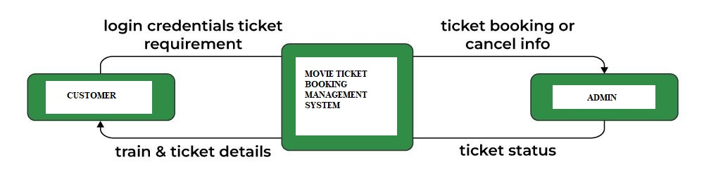

**Data Flow Diagram**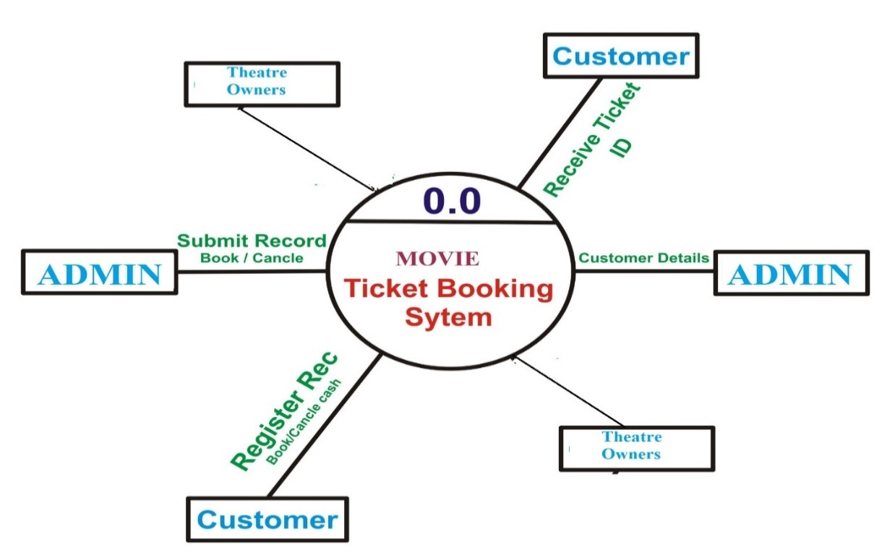

**ER Diagram**

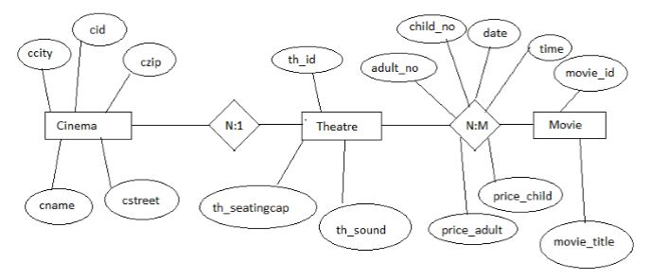

**Schema Diagram**

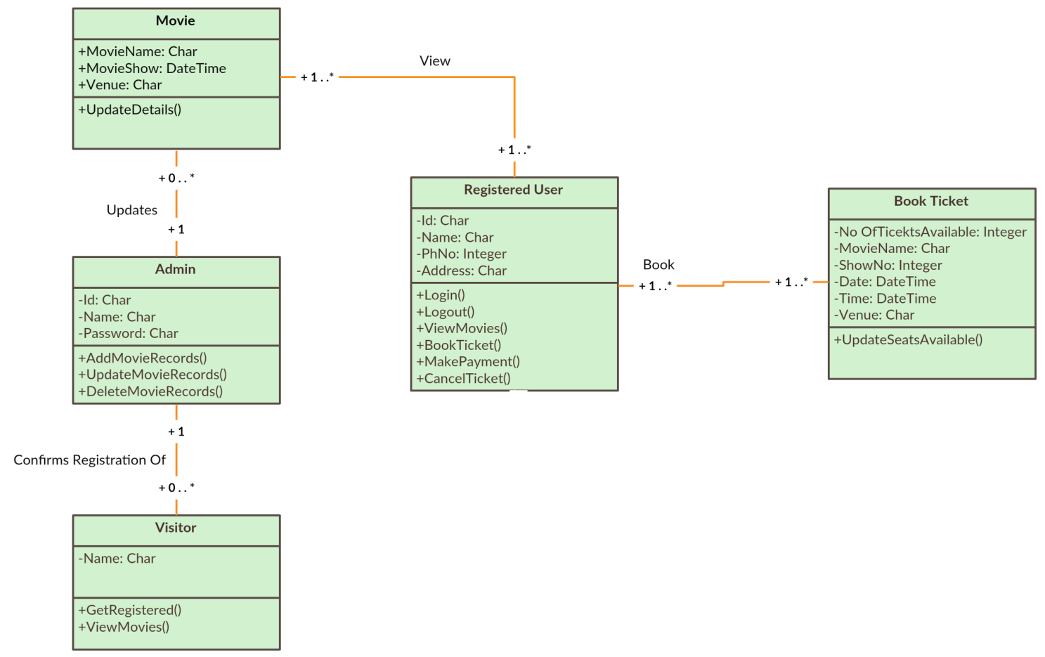

**Objectives of the work**

* The main objective of this internship was to gain hands on experience in real life situations and observe how an industry works.
* Assigned as an intern , I was mainly told to observe the process of developing a project. I worked along with the Engineers, throughout the process that provided me with various knowledge and experience on how to convert a concept or an idea into reality.

**Technologies Learnt**

* Java
* GUI Development
* Storage with Database, File Storage and Cloud Storage
* AWS Services

**Internship Road Map**

**Use Case 2 for Interns**

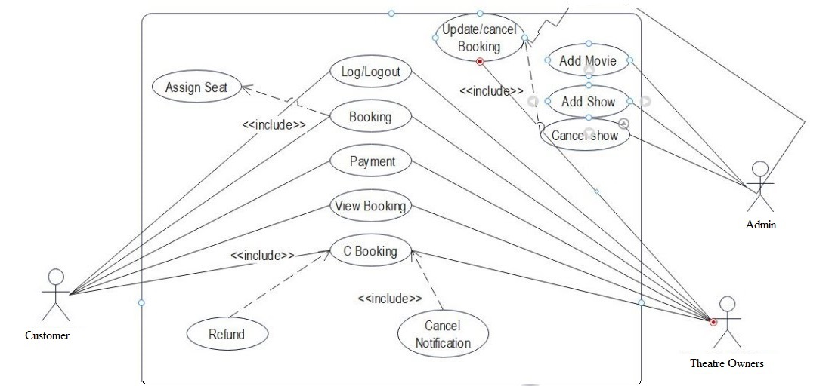

**CHAPTER-2**

**2.1 User Stories for Customer Registration**

**Customer Registration:**

As a < unauthorized user >

I want to < sign up for the MovieTicketBooking application through a sign-up form >

So that < I can access to movies list. >

## Acceptance Criteria:

1. While signing up-Use Name, Username, Email, and Password and Confirm Password.
2. If sign up is successful, it will get automatically logged in.
3. If I sign up with an incorrect detail which are specified in step1, I will receive an error Message for incorrect information.
4. If we are trying to sign up with an existing email address, we will receive an error Message saying "email exists."

**2.2 User Stories for Customer Login**

**Customer Login:**

As a < authorized user >

I want to < log in for MovieTicketBooking application >

So that < I can have access to the application.

## Acceptance Criteria:

1. While logging in, Username and password are required.

2. After successful log in, it will be redirected to the main page.

3. If we are trying to login with incorrect username or password, then error message will be displayed as "invalid login”.

**2.3 User Stories for Search Movie**

**Search Movie:**

As a < user >

I want to < search for a movie in MovieTicketBooking Application>

So that < I can book a Movieticket in a specific theater.>

**Acceptance Criteria:**

1. While searching, Valid theater should be specified.

2. And also, Available movie in the theater.

3. Checking for availability of a Movieticket on specific date always should be current date and ahead of the current date.

4. Searching based on the theater Location.

5. Price listing as per the theater.

**2.4 User Stories for View Movie Details**

**View Movie Details:**

As a < user >

I want to < view the movie details in a Particular movie >

So that < I can easily book the movie ticket in the application >

**Acceptance Criteria:**

1. While view the movie details, its show the current theater name, movie name and show timings.

2. And also, show remaining tickets available.

3. Checking about the movie description of the particular movie.

4. And also shows the movie ticket price.

5. Also view the new trending movie details.

6. View Trailers of currently running movies.

7. Shows the QR code or ticket number.

**2.5 User Stories for TheaterOwner Registration**

**TheaterOwner Registration:**

As a < unauthorized user >

I want to < sign up for the MovieTicketBooking application through a sign-up form >

So that < I can access to movies list. >

## Acceptance Criteria:

1. While signing up-Use Name, Username, Email, and Password and Confirm Password.

2. If sign up is successful, it will get automatically logged in.

3. If I sign up with an incorrect detail which are specified in step1, I will receive an error

Message for incorrect information.

4. If we are trying to sign up with an existing email address, we will receive an error Message saying "email exists."

**2.6 User Stories for Theater Owner Login**

**Theater Owner Login:**

As a < authorized user >

I want to < log in for Movie Ticket Booking application >

So that < I can have access to the application. >

## Acceptance Criteria:

1. While logging in, Username and password are required.

2. After successful log in, it will be redirected to the main page.

3. If we are trying to login with incorrect username or password, then error message will be displayed as "invalid login”.

**2.7 User Stories for Add Movie and Show**

**Timings**

**Add Movie:**

As a < admin >

I want to < add movies to the MovieTicketBooking application >

So that < the customer’s can easily book the movie tickets >

**Acceptance Criteria:**

1. While adding the movie to the application, to add the movie name, theater name, add timings.

2. And also add the movie timings and price.

3. Adding the Sessions of the all movies.

4. particular movie payment system are also added.

5. Add the theater location.

**Show Timings:**

As a < admin >

I want to < show timings of the particular movie and sessions >

So that < the customer can book movie tickets based on the their available timings >

**Acceptance Criteria:**

1. While view the movie details then show the particular movie timings.

2. Timings based on the morning ,afternoon and

night sessions.

3. Showing the Upcoming movies timings list.

**2.8 User Stories for Edit Movie.**

**Edit Movie:**

As a < admin >

I want to < Edit the movies >

So that < the customer’s can easily view and book the current and available movies only >

**Acceptance Criteria:**

1. In the edit page should be display the edit option of the all field.

2. While Edit the movie name, movie session, movie theater .

3. And also edit the theater location, movie timings.

4. delete the unavailable movie in the application.

5. Edit the only available theater in the current location.

6. Only shows the available timings in the current theater.

**2.9 User Stories for Booking Movie.**

**Booking Movie**

As a < user >

I want to < be able to make a booking for a specific movie >

So that < I can book Online >

**Acceptance Criteria:**

1. In the booking page should be display the booking details for the particular movie

2. In booking home page its display the fields for

entering the customer name, movie name, theater name

and also book button field for finally book the movie.

3. Booking the movie based on the trending list.

4. book the movie based on the near location theater available.

5. booking the movie in particular session.

6. Select the particular theater and movie.

**2.10 User Stories for Logout**

As a < authorized user >

I want to < log out of application >

so that < I can prevent unauthorized access of my profile. >

**Acceptance Criteria:**

When I log out of my account, I will be redirected to the log-in page**.**

**CHAPTER-3**

**3.1 Test Cases for Customer Registration**

**Test Case 1: Customer Registration**

**Description:** Verify that the details are correctly valid in the registration page.

**Steps:**

1. Navigate to the Registration page in Home page.

2. Verify that the all details are validate the information of the new customer.

**Expected Result:** If the Customer are Enter the Correct details is Successfully Registration.

**3.2 Test Cases for Customer Login**

**Test Case 2: Customer Login**

**Description:** Verify that the details are correctly valid in the Login page.

**Steps:**

1. Navigate to the Login page in Homepage.

2. Verify that the all details are validate the information of the new customer.

**Expected Result:** If the Customer are Enter the Correct details is Successfully Registration.

**3.3 Test Cases for Search Movie:**

**Test Case 1: Search Bar Display**

**Description:** Verify that the Search bar is displayed correctly.

**Steps:**

1. Navigate to the search bar in Home page.

2. Verify cursor should present on click on the

search icon.

**Expected Result:** The Search bar is correctly shown on the Home page.

**Test Case 2: Valid Result Display.**

**Description:** Enter a valid movie name and ensure relevant results are displayed.

**Steps:**

1. Navigate to the Home page.

2. Click on the “Search Bar”.

3. Enter the valid movie name.

**Expected Result:** If Enter the valid movie name and relevant results are display in the search bar.

**Test Case 3: Test the Real-time Suggestions are Display.**

**Description:** Test the "Search As You Type" feature for real-time suggestions.

**Steps:**

1. Navigate to the Home page.

2. Click on the “Search Bar”.

3. Enter the valid movie name.

**Expected Result:** If in the Search bar Type the any movie name its display the **“**Suggestions**”** for what we type in the Search bar.

**Test Case 4: Search history displayed**

**Description:** Check if the search history is displayed.

**Steps:**

1. Navigate to the Home page.

2. Click on the “Search Bar”.

**Expected Result:** If we click on the search bar it show(or) display the “Search History”.

**3.4 Test Cases for View Movie Details:**

**Test Case 1: View Button Display**

**Description:** Verify that the View Button is display correctly.

**Steps:**

1. Navigate to the home page.

2. Click on the Menu button.

3. Verify the view button is display in the menu bar.

**Expected Result:** The View Button is correctly shown on the Home page.

**Test Case 2: View the available movie.**

**Description:** View the available movie are display in the page.

**Steps:**

1. Navigate to the home page.

2. click on the view Button.

**Expected Result:** If we click on the view button

then it display the all available movies in the application.

**Test Case 3: View the movie ticket price.**

**Description:** Check the movie ticket price are display in the page.

**Steps:**

1. Navigate to the home page.

2. click on the view Button.

3. View the particular movie ticket price.

**Expected Result:** Display the Current price’s for the particular movie ticket.

**Test Case 4: Display the Movie description.**

**Description:** Check the movie description are display in the page.

**Steps:**

1. Navigate to the home page.

2. click on the view Button.

3. View the particular movie ticket price.

4. check the that movie description are display.

**Expected Result:** Display the movie description for the particular movie.

**3.5 Test Cases for Theater Owner Registration**

**Test Case 1: Theater Owner Registration**

**Description:** Verify that the details are correctly valid in the registration page.

**Steps:**

1. Navigate to the Registration page in Home page.

2. Verify that the all details are validate the information of the new Theater Owner.

**Expected Result:** If the Theater Owner are Enter the Correct details is Successfully Registration.

**3.6 Test Cases for Theater Owner Login**

**Test Case 1: Theater Owner Login**

**Description:** Verify that the details are correctly valid in the Login page.

**Steps:**

1. Navigate to the Login page in Home page.

2. Verify that the all details are validate the information of the new TheaterOwner.

**Expected Result:** If the TheaterOwner are Enter the Correct details is Successfully Login.

**3.7 Test Cases for Add Movie and Show Timings**

**Add Movie:**

**Test Case 1: Add Button Display**

**Description:** Verify that the Add Button is displayed correctly.

**Steps:**

1. Navigate to the Add button in Home page.

2. Verify cursor should present on click on the Add button.

**Expected Result:** The Add Button is correctly shown on the Home page.

**Test Case 2: Invalid Movie name**

**Description:** Enter the in Invalid Movie name.

**Steps:** Add an unavailable or invalid movie name, Enter valid check-in and check-out dates, provide necessary details, confirm the movie name

**Expected Result:** Display an error message indicating that the selected movie name.

**Test Case 3: Valid Movie name**

**Description:** Enter the in valid Movie name

**Steps:** Add an available or valid movie name, Enter valid check-in and check-out dates, provide necessary details, confirm the movie name

**Expected Result:** Display an Successfully Added message indicating that the added movie name is valid.

**Show Timings:**

**Test Case 1: Show Button Display**

**Description:** Verify that the Show Button is displayed correctly.

**Steps:**

1. Navigate to the Show button in Home page.

2. Verify cursor should present on click on the Show button.

**Expected Result:** The Show Button is correctly shown on the Home page.

**Test Case 2: Invalid Movie Timings**

**Description:** Enter the in Invalid Movie name.

**Steps:** Enter an unavailable or invalid movie timings, Enter valid check-in and check-out dates, provide necessary details, confirm the movie timings.

**Expected Result:** Display an error message indicating that the Enter movie timings are invalid.

**3.8 Test Cases for Edit Movie**

**Test Case 1: Edit Button Display**

**Description:** Verify that the Edit Button is display correctly.

**Steps:**

1. Navigate to the home page.

2. Click on the Menu button.

3. Verify the Edit button is display in the menu bar.

**Expected Result:** The Edit Button is correctly shown on the Home page.

**Test Case 2: Edit Movie Name**

**Description:** Verify that the Edit Movie name is correctly working or not.

**Steps:**

1. Navigate to the home page.

2. Verify the Edit button is display in the menu bar.

3. Edit movie current name to modify the new name.

4. After Edit Redirect to the home page.

5. Check the Modify name.

**Expected Result:** Modify New name is current display in the home page.

**Test Case 3: Edit Theater Name**

**Description:** Verify that the Edit Theater name is correctly working or not.

**Steps:**

1. Navigate to the home page.

2. Verify the Edit button is display in the menu bar.

3. Edit theatre current name to modify the new name.

4. After Edit Redirect to the home page.

5. Check the Modify name.

**Expected Result:** Modify New name is current display in the home page.

**Test Case 4: Display only available movies**

**Description:** Verify after Modify its display only available movies remaining are deleted.

**Steps:**

1. Navigate to the home page.

2. Check the movies name’s are display.

4. It’s show only the trending and new current movies are available in the Theater.

**Expected Result:** It display the current movie in the current theater.

**3.9 Test Cases for Booking Movie.**

**Test Case 1: Booking Button Display**

**Description:** Verify that the Booking button is displayed correctly.

**Steps:**

1. Navigate to the booking button in Home page.

2. Verify the booking button is action to when finally book the movie ticket.

**Expected Result:** The booking button is correctly shown on the Home page.

**Test Case 2: Display accurate information**

**Steps:** Type or Search the particular movie name.

**Expected Result:** Ensure that the ticket booking page display accurate information about the event, such as the date, time and venue

**Test Case 3: Invalid Movie name**

**Steps:** Select an unavailable or invalid movie name, Enter valid check-in and check-out dates, provide necessary details, confirm the movie name

**Expected Result:** Display an error message indicating that the selected movie name.

**Test Case 4: Invalid Date**

**Steps:** Select an unavailable or invalid movie name, Enter valid check-in and check-out dates, provide necessary details, confirm the movie date.

**Expected Result:** Display an error message indicating that the selected movie date is unavailable.

**Test Case 5: Invalid Theatre name**

**Steps:** Select the invalid or unavailable theater name for booking the movie ticket.

**Expected Result:** Display an error message indicating that the selected invalid or unavailable movie name.

**Test Case 6: Invalid Movie Session’s**

**Steps:** Select the invalid or unavailable movie sessions for booking the movie ticket.

**Expected Result:** Display an error message indicating that the selected invalid or unavailable movie session.

**Test Case 7: Invalid Movie timings**

**Steps:** Select the invalid or unavailable movie timings for booking the movie ticket.

**Expected Result:** Display an error message indicating that the selected invalid or unavailable movie timings.

**Test Case 8: Invalid Movie Location**

**Steps:** Select the invalid or unavailable movie location for booking the movie ticket.

**Expected Result:** Display an error message indicating that the selected invalid or unavailable movie location.

**Test Case 9: Valid or Available details.**

**Steps:** Enter the valid or available movie name, date, theater name, Sessions, timings, location and Payment details.

**Expected Result:** Display an Successfully booking message. If the all details are correctly.

**3.10 Test Cases for Logout.**

**Test Case 1: Verify Logout Button**

**Description:** Verify that the Logout Button is display correctly and Logout from the application.

**Steps:**

1. Navigate to the home page.

2. Click on the Menu button.

3. Verify the Logout button is display in the menu bar.

4. Click the logout Button.

5. Redirect to the Login page.

**Expected Result:** The View Button is correctly shown on the Menu Bar and When Logout its Successfully Redirect to the Login page.